План-конспект уроку в 6 класі за темою

**«Тур Україною»**

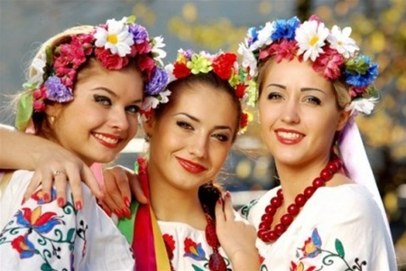

**Цілі:** практикувати словарний запас, сформувати основні знання по темі «Україна», розвивати навики діалогічного та монологічного мовлення, складання запитань та відповідей на них, аудіювання, формувати цікавість до країни, де живеш;

Тип уроку: комбінований

Обладнання: карта світу, карта Європи, презентація, фрагмент фільму про Україну та Крим. Фрагмент фільму «Вечори на хуторі близь Диканьки».

Хід уроку:

1. Організаційний момент:

* Привітання, бесіда з черговим.

Учні задають всі можливі запитання черговому.

* Повідомлення теми та мети уроку:

Today we’ll speak with you about Ukraine and Ukrainians. You’ll see pictures of different cities of Ukraine listen to stories about history and places of interest of some big cities. We’ll make an excursion around Ukraine.

1. Основна частина уроку:

* Актуалізація опорних знань:

Teacher: What associations do you have with the words Ukraine and Ukrainians: capital, population, territory, mountains, seas, cities, rivers, lakes, is washed by?

Now, make sentences using these words.

* Listen to the poem:

Ukraine, the native land of mine,

You suffered much. You’ve lost the sons of thine.

But you managed to become free again

And stayed young through fights and pain.

* Формування образу народу та країни:

Where can we read about the beauty of our country?

What Russian and Ukrainian writers and poets mention about Ukraine?

* Мовлення:

And now let’s talk about places of interest of Ukraine and some cities.

**П’ять - шість екскурсоводів дають опис міста, його місць. Слухачі задають запитання, аби отримати додаткову інформацію.** В цей час фоном служить фільм про Україну.

* Riddles

In this box I’ve hidden something that is connected with our country/ Take my hints:

It is closely connected with the history of Kyiv Rus;

The famous prince is on this thing;

It is made of paper, it is not very big and you can find it in a wallet or a purse. (hryvna)

Battle

Play a team game. One team has to ask questions as many as possible and another one has to answer them correctly. The winner is that team, who asks more questions. (надати учня зразки запитань зі спеціальними словами).

1. Закріплення вивченого матеріалу:

* Before listening:

Answer the questions:

What is the territory of Ukraine?

What is the population of Ukraine?

What is the national currency?

What ancient Ukrainian cities do you know?

What is the biggest river of Ukraine?

What is the symbol of Kyiv?

Who is the founder of Kyiv?

Where is Ukraine situated?

What mountains are there in Ukraine?

What is the national Ukrainian dish?

* Listening

Listen to the text and decide if the sentences are true or false:

*Ukraine is a very old country with a great and long history, customs and traditions. The history of Ukraine dates back to the days of Kyiv Rus. It was first mentioned in the ninth century. It was the state which united three nations: the Russians, the Ukrainians and the Byelorussians; it is situated at the territory of modern Ukraine. Ukraine is one of the biggest countries in Europe, it borders on Poland, Slovakia, Romania and Russia.*

*Ukraine is famous for its ancient cities such as Kyiv, Chernigov, Poltava and many others, which have seen triumphs and fails, great fights, victories and defeats. Ukraine is also known for its Cossacks, great and brave defenders of the Ukrainian land.*

* Post – listening:

Ukraine was mentioned in the eleventh century.

The history of Ukraine dates back to the days of Kyiv Rus.

It was the state which united three nations: the Russians, the Ukrainians and Poles.

it borders on Poland, Slovakia, Romania and Kazakhstan.

Our closest neighbor is Russia.

Ukrainian ancient cities are Kyiv, Chernigov, Poltava and many others.

1. Заключна частина уроку:

* Підведення підсумків, оцінювання.
* Повідомлення домашнього завдання.